

MATLAB-EXPERIMENT-4A

Double Integrals and change of order of integration



march 26, 2021

BIMAL PARAJULI

20BDS0405

Department of Mathematics

School of Advanced Sciences

MAT 1011 – Calculus for Engineers (MATLAB)

Experiment 4-A

Double Integrals and change of order of integration

Prepared by: Bimal parajuli

Registration Number: 20BDS0405

**Question 1:**

**Find the volume of the solid S that is bounded by the elliptic paraboloid x2+2y2+z=16, the planes x = 2 and y = 2 , and the three coordinate planes.**

**CODES:**

close all;

clear;

clc;

syms x y z;

func(x, y) = 16 - x^2 - 2* y^2;

disp('The volume enclosed by the surface is')

int(int(func, y, 0, 2), x, 0, 2)

figure(1)

viewSolidone(z, 0 + 0 *x + 0 * y, func, y, 0 + 0*x, 2 + 0*x, x, 0, 2);

xlabel("X-axis");

ylabel("Y-axis");

zlabel("Z-axis");

**OUTPUT:**

The volume enclosed by the surface is  
   
ans =  
   
48

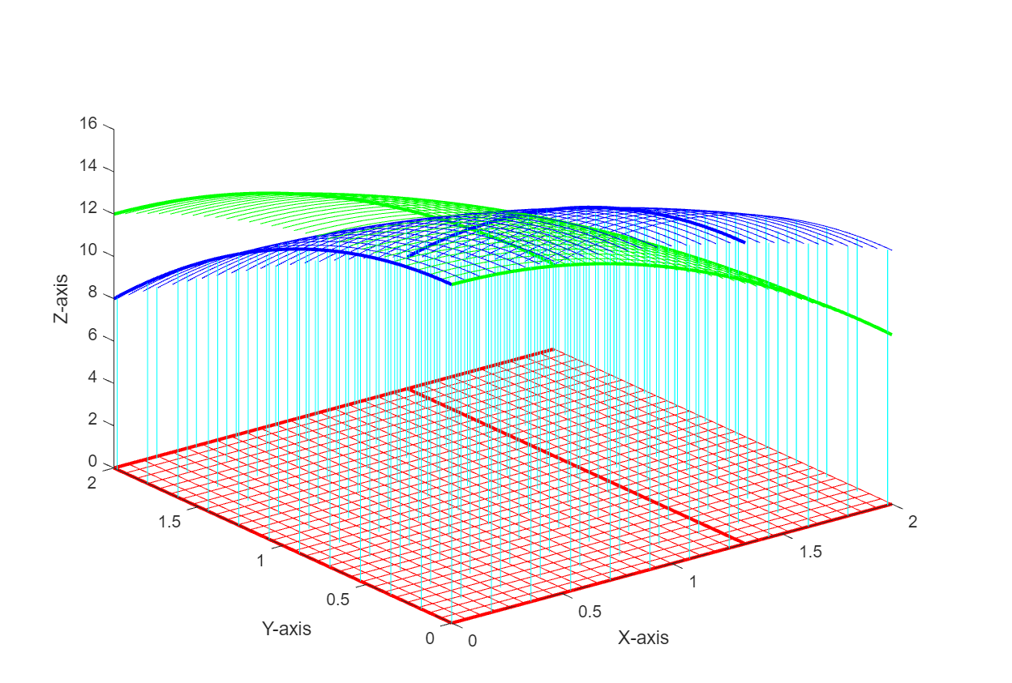

**Question 2:**

**Evaluate ∫∫ sin x cos y dA where R = [0, π /2] × [0,π /2].**

**CODES:**

close all;

clear;

clc;

syms x y z;

func(x, y) = sin(x) * cos(y);

disp('The volume enclosed by the surfaces is')

int(int(func, y, 0, pi/2), x, 0, pi/2)

figure(1)

viewSolidone(z, 0 + 0 *x + 0 * y, func, y, 0 + 0*x, pi/2 + 0*x, x, 0, pi/2);

xlabel("X-axis");

ylabel("Y-axis");

zlabel("Z-axis");

**OUTPUT:**

The volume enclosed by the surfaces is  
   
ans =  
   
1

